L&B Experience achieves Travelife Partner level

Amsterdam, June 10th, 2025. The Travelife Partner level award was received today by L&B Experience (Thailand). The award recognizes the long-term efforts of L&B Experience regarding sustainability and Corporate Social Responsibility.

L&B Experience complies with more than 100 criteria, related to an operator’s office management, product range, international business partners and customer information. The Travelife Partner level standard is covering the ISO 26000 Corporate Social Responsibility themes, including environment, biodiversity, human rights and labour relation.

Mr. Naut Kusters, manager of Travelife for Tour Operators, “I am delighted to see that sustainability in the tour operator sector is obtaining momentum. The Partner award of L&B Experience will inspire other companies in Thailand to follow the same path’.

Travelife is the leading international sustainability certification for the travel sector. More than 35 national travel associations are promoting the scheme to their members including ABTA (UK), ANVR (NL), PATA (Asia), FTT (South Africa), SMAL (Finland), UHPA (Croatia), JARTA (Japan), APAVT (Portugal) and more.

We would also like to thank our partner Evaneos, who connects us with travellers seeking more sustainable trips, for their support in achieving this award.

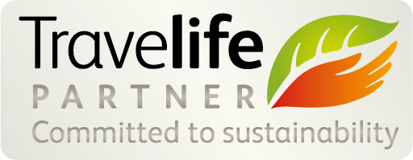

Editor notes

Travelife for Tour operators & Travel agents
Naut Kusters, phone +31 6 48805 475
n.kusters@travelife.info
www.travelife.info

About Travelife (www.travelife.org)
Travelife is a certification system, dedicated to achieving sustainable practices within the tourism industry. It provides companies with realistic sustainability goals, tools and solutions to implement positive change within their businesses and supply chains. Travelife is managed by ABTA – The Travel Association in the UK - and by ECEAT Projects - a not-for-profit organisation based in The Netherlands. Travelife has two key focuses:

Travelife for Tour operators and Travel agents: the scheme provides online training and practical tools for sustainability management and certification. The training and online tools are suitable for tour operators and travel agencies of any size and cover all management aspects of the travel company business including office operations, the supply chain, destinations and consumers. Upon submitting a report in compliance with the Travelife standard (based on an independent onsite audit), the company can obtain the “Travelife Certified” status.
The Travelife standard for Tour operators and Travel agencies is based upon the full Corporate Social Responsibility themes, including labour conditions, human rights, environment, biodiversity and fair business practices. The management requirements are compatible with EMAS and ISO 14001. The system is supported by more than 35 national travel associations to further its implementation among members.

//////

